Customer Segmentation Platform

Introduction
Customer behavior plays an important role in the growth and success of any business. Businesses generate large amounts of transaction data through customer purchases, but small businesses often lack the tools and technical expertise required to analyze this data effectively. As a result, they may not know which customers are valuable, which customers are loyal, and which customers are becoming inactive.
Our project proposes a Segmentation Platform that helps businesses understand their customers using Data Science and Machine Learning. The system analyzes transaction data using RFM (Recency, Frequency, and Monetary) analysis and clustering techniques to identify customers with similar purchasing behavior.
The platform provides two demo company datasets on the landing page so that users can understand how the system works. After logging in, a business user can upload their own transaction data in CSV/Excel format and access a personalized dashboard. The system processes the uploaded data, calculates customer behavior metrics, applies K-Means and DBSCAN clustering, and uses PCA to visualize the resulting customer groups. Instead of displaying technical cluster numbers, the system provides understandable labels such as Loyal High Spenders, Potential Loyal Customers, At-Risk Customers, and Dormant Customers. Based on these segments, the platform provides useful insights and recommendations that can help small businesses make better customer-retention and marketing decisions

What Does Project Do / Features
1. Demo Company Analysis
The landing page contains two preloaded company datasets. Users can explore these examples to understand customer segmentation and the type of insights generated by the system.
2. User Login and Dashboard
Registered users can log in and directly access their personalized business dashboard. Their uploaded data and analysis are associated with their account.
3. Upload Own Transaction Data
Businesses can upload their own CSV or Excel transaction data. The system validates and preprocesses the data before performing the analysis.
4. RFM Analysis
The system calculates:
- Recency – How recently the customer purchased.
- Frequency – How frequently the customer purchases.
- Monetary – How much the customer spends.
These values help understand customer purchasing behavior.
5. Customer Segmentation
The system applies K-Means and DBSCAN clustering algorithms to group customers based on similarities in their purchasing behavior.
6. PCA Visualization
Principal Component Analysis (PCA) is used to reduce the customer data into two dimensions so that the different customer clusters can be displayed visually on the dashboard.
7. Business-Friendly Customer Labels
The technical clusters are converted into meaningful categories such as:
- Loyal High Spenders
- Potential Loyal Customers
- New Customers
- At-Risk Customers
- Dormant Customers
8. Business Insights and Recommendations
The system provides recommendations based on customer segments. For example, high-value customers can be targeted with loyalty rewards, while at-risk customers can be targeted with personalized offers or re-engagement campaigns.

Work Flow
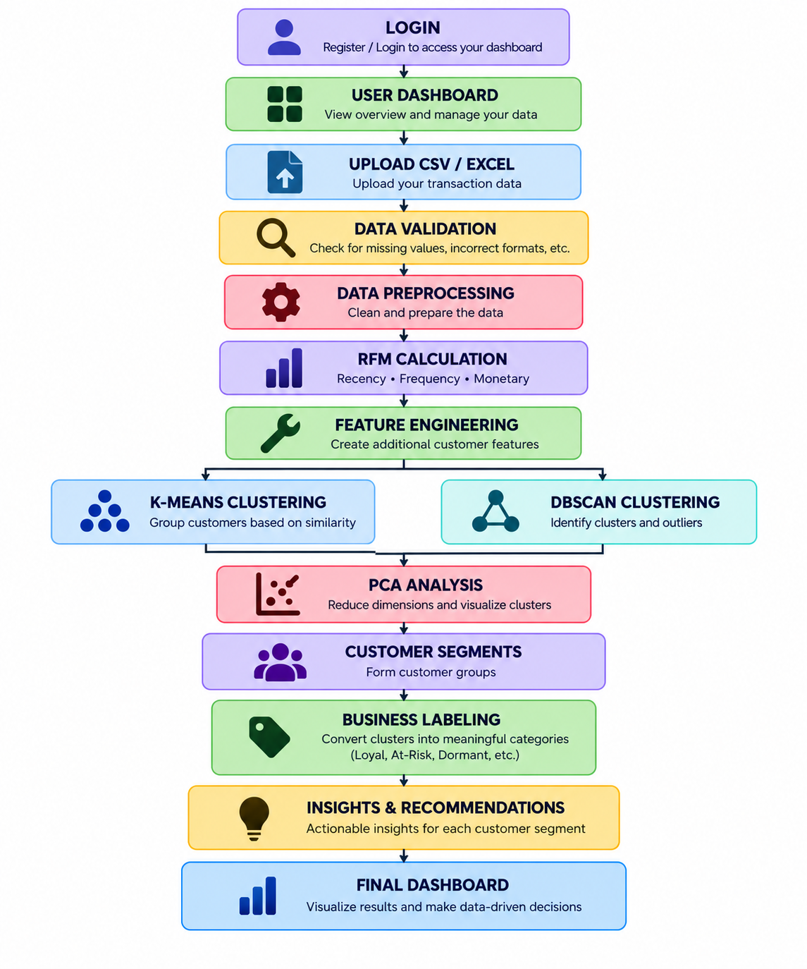

Technology Stack
Category | Technology / Tools | Purpose
Frontend | HTML, CSS, JavaScript | Designing the web interface and dashboard
Backend | Python, Flask | Server-side application logic and API development
Data Processing | Pandas, NumPy | Data cleaning, preprocessing and feature engineering
MachineLearning | Scikit-learn | K-Means, DBSCAN, PCA and clustering evaluation
Data Visualization | Matplotlib, Seaborn, Plotly | Visualizing customer segments and analytical results
Database | MySQL | Storing user, company, transaction and analysis data
Development Tools | VS Code, Jupyter Notebook, Git/GitHub | Development, experimentation and version control

Conclusion

The platform combines Data analysis with an easy-to-understand web interface, presenting technical results as meaningful customer categories and business recommendations. The inclusion of demo company datasets allows users to understand the system before uploading their own data. Overall, the project aims to help small businesses make data-driven decisions for customer retention, marketing, and business growth.

